Lab-5 Network Forensics
Objective
The objective of this experiment is to understand the fundamentals of network forensics by analyzing captured network traffic using forensic tools. Students will learn how to examine packet capture files, identify communication between hosts, and reconstruct artifacts transmitted over the network.
The experiment aims to:
- Analyze network traffic using Wireshark.
- Identify important network information such as IP addresses, ports, and protocols.
- Extract files and artifacts from packet captures using NetworkMiner.
- Reconstruct network artifacts such as images, files, sessions, and hosts from captured traffic.
- Investigate malicious network activity and analyze malware communication patterns from packet captures.

Network Traffic Analysis: Host Foot-printing and File Extractions
In this activity you will use Wireshark to review the results of a previously recorded connection between a host and a web server.
Instructions and Questions:
- Download the following packet capture: “Website-Visit.pcapng.”
- Launch Wireshark.
- Open the file named “Website-Visit.pcapng.” provide the Screenshot of the results
- What is the IP address of the visited web site?
In the textbox above the packet information tabs enter the following text to filter the results looking for packets with the SYN flag set: tcp.flags.syn==1.

- On what port is the web server listening?

In the Packet List Pane, right-click on the packet numbered 1 and from the pull-down menu select “Follow TCP Stream” as shown below.
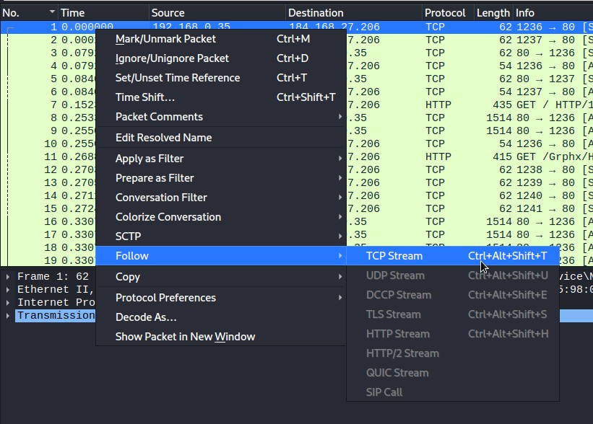

provide a screenshot of the “Follow TCP Stream” page. And answer the following

- What is the name of the web site, which was visited?

- Was the connection to the web site successful from the server’s point of view?

- What kind of web platform is being used to host the server?

- When was this visited web page last updated by the web author/provider?

- When was this particular web page accessed?

Click the “Close” button.
Click the X button, at the end of the textbox to clear the filter, which was automatically applied.
In Wireshark’s Packet List Pane, click on packet 7, which has the protocol of HTTP.
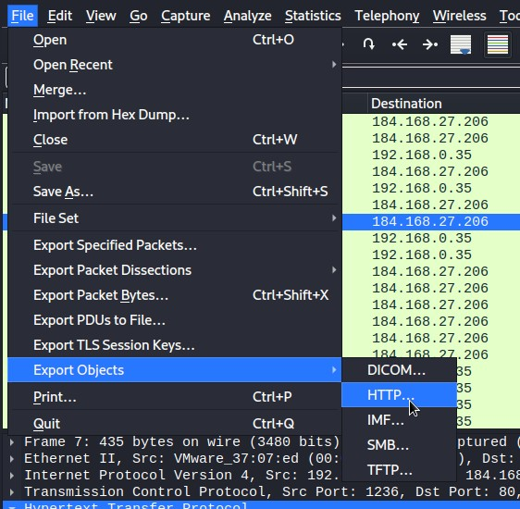
- To recover artifacts from the network packet capture, go to the main menu, select “File” select “Export objects,” and then select “HTTP”).

After selecting “HTTP,” the list of exportable objects will be presented. Click an object to recover and click the “Save” button. Provide a screenshot.

Network Artifact Reconstruction using NetworkMiner
In this activity you will use NetworkMiner to analyze the same packet capture and automatically reconstruct artifacts such as hosts, files, images, and sessions.

Instructions
- Download and extract NetworkMiner from the official website.
- Launch NetworkMiner.
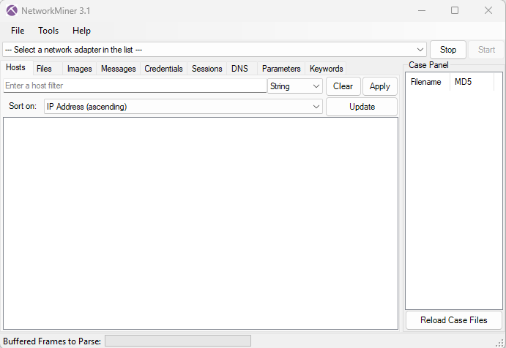
- From the menu select File → Open.
- Open the previously used packet capture file:
Website-Visit.pcap
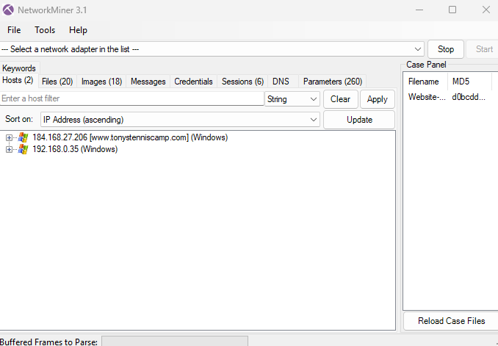
- NetworkMiner will automatically begin analyzing the network traffic.

Hosts Analysis
Open the Hosts tab.
This tab displays the systems detected in the network communication.
- What is the IP address of the web server identified in the Hosts tab?

Files Reconstruction
Open the Files tab.
NetworkMiner automatically reconstructs files transferred through the network.
These files may include:
- HTML files
- images
- scripts
- How many files were reconstructed from the packet capture?
- What types of files were extracted?

Image Reconstruction
Open the Images tab.
NetworkMiner reconstructs images from HTTP traffic.

Question
- How many images were reconstructed from the network traffic?

Session Analysis
Open the Sessions tab.
This tab displays communication sessions between hosts.
- Which protocol is used for the communication session between the client and server?

Credential Detection
Open the Credentials tab.
NetworkMiner may extract authentication data if present.
- Were any credentials detected in the packet capture?

Artifact Export
NetworkMiner allows saving reconstructed artifacts. It will export automatically to this path
C:\Users\<username>\AppData\Local\NetworkMiner\AssembledFiles
- Export recovered file from the capture and record its file names. Provide a screenshot.

Malware traffic analysis
For this lab we will be taking a look at the network traffic sent by systems infected with a malware known as Trickbot. Trickbot is often distributed through malspam. Emails from these campaigns contain links to download malicious files disguised as invoices or documents. These files may be Windows executable files for Trickbot, or they may be some sort of downloader for the Trickbot executable. In some cases, links from these emails return a zip archive that contains a Trickbot executable or downloader.
This Trickbot infection is in an Active Directory (AD) environment where the infection spreads to the Domain Controller (DC). We will aim to understand the network traffic and answer the following questions:
- Based on the Trickbot infection's HTTP POST traffic, what is the IP address, host name, and user account name for the infected Windows client?
- What is the other user account name and other Windows client host name found in the Trickbot HTTP POST traffic?
- What is the infected user's email password?
- Two Windows executable files are sent in the network traffic. What are the SHA256 file hashes for these files?
Instructions:
- Download the following packet capture: MalwareTraffic-1.zip. This zip is encrypted and the password for it is “infected”
- Launch Wireshark.
- From the main menu select “File,” select “Open,” and then open the file namedMalwareTraffic-1.pcap.
- When Trick bot successfully infects a Windows host, it sends an HTTP POST request with the system data, usually over TCP port 8082. The URL ends with /90, so use the following Wireshark filter to find that URL and follow the TCP stream:

http.request.uri contains "/90"
This should return two URLs in your Wireshark column display, one for the infected Windows client (CAT-BOMB-W7-PC), and one for the domain controller (CATBOMBER-DC).
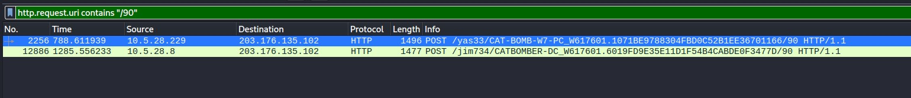
Now we right click the first packet, numbered 2256, and select follow, then TCP stream.
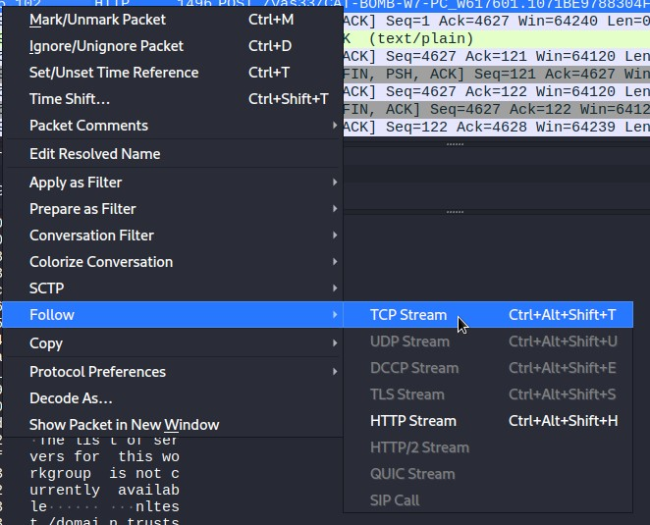
- Now answer the following and provide the screenshots:
Infected Windows client IP address:
Infected Windows client host name:
Infected Windows client user account name:
Other Windows client host name:
Other Windows client user account name:

- Click the “Close” button to close the “Follow TCP stream window”.
- Click the X button, at the end of the textbox to clear the filter, which was automaticallyapplied.
- HTTP POST requests that end in "/81" is where we find password data exfiltrated from aninfected Windows host. Use the following Wireshark filters to find email passwords:

http.request.uri contains "/81" and ip
- Right-click on the packet numbered 1600 and from the pull-down menu select “Follow”,and then “TCP Stream” provide the screenshot.
- Here we can find the password used by user Phillip Ghent answering our third question.
User Philip Ghents email password:
- Click the “Close” button to close the “Follow TCP stream window”.
- Click the X button, at the end of the textbox to clear the filter, which was automatically applied.
- We can quickly filter on traffic to see if there's any Windows executable (EXE) files pass int he clear (not as encoded or encrypted data) using the following filter:

ip contains "This program"
This doesn't work every single time, but it works for most EXE files. It should return two frames in your column display. Follow each of these TCP streams.

- We now have the names of the two .png extension executables and we can now export the two files so that we can find their hash values. Please DO NOT execute these files or try to open them as these are malicious executables and can infect your system.
- To recover artifacts from the network packet capture, go to the main menu, select “File,”select “Export objects,” and then select “HTTP”.
- After selecting “HTTP,” the list of exportable objects will be presented. Click on the two image files and click the “Save” button.
- To find the hash values of these files we can use sha256sum on linux or Get-FileHash on windows to find the hash values of the files. Provide the screenshot

